Multithreaded Programming Basics Assignments
- Which applications can be multithreaded?

Multithreaded applications are the ones that use the concept of Concurrency i.e. they are capable of processing more than one task in parallel. A simple example could be a word document in which, spell-check, response to keyboard, formatting, etc happens at the same time or Concurrently.

- Which applications cannot be multithreaded?

On a single processor server and a web based app, no need for multi-threading because the web server handles most of it.

- How to create or use POSIX threads?

In Linux platforms, the C and C++ languages pthread standard API for all kinds of thread-related functions. It is also known as a POSIX thread that allows users to create many threads for simultaneous processes to flow
We must include the pthread.h header file at the beginning of the script to use all the functions of the pthreads library.

pthread_create:
It is used to create a new thread.
Syntax:

int pthread_create (pthread_t * thread, const pthread_attr_t * attr,
void *(*start_routine)(void *), void * arg)

- thread: pointer to an unsigned integer value that returns the thread id of the thread created.
- attr: pointer to a structure that is used to define thread attributes like detached state, scheduling policy, stack address, etc. Set to NULL for default thread attributes.
- start_routine: pointer to a subroutine that is executed by the thread. The return type and parameter type of the subroutine must be of type void *. The function has a single attribute but if multiple values need to be passed to the function, a struct must be used.
- arg: pointer to void that contains the arguments to the function defined in the earlier argument

- How to compile and execute the program using POSIX threads API. Mention the statements to compile a file mythread.c and generate an executable “mythread”.
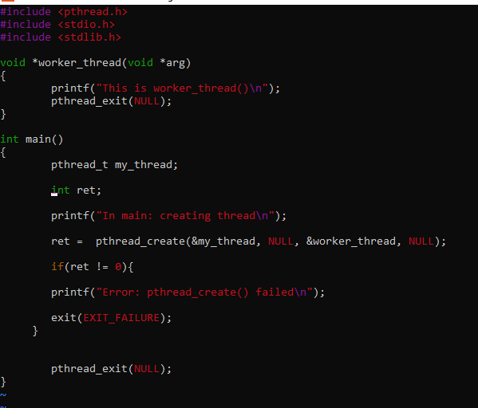
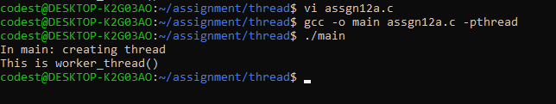

- Is mutex the same as semaphore?
A Mutex is different than a semaphore as it is a locking mechanism while a semaphore is a signaling mechanism. A binary semaphore can be used as a Mutex but a Mutex can never be used like a semaphore.

- What is the difference between mutex and semaphore? Can we use mutex as a semaphore and vice versa?

Semaphore
- It is used in the signalling mechanism.
- It is an integer variable.
- The ‘wait’ and ‘signal’ operations can be used to modify a semaphore.
- If no resources are available, the process requires that a resource that needs to be executed has to ‘wait’.
- The process will have to ‘wait’ until the count of the semaphore is higher than 0.
- Multiple program threads can be used with a semaphore.
- The value of a semaphore can be changed by any process that releases or obtains the resource.
- There are different kinds of semaphores: Counting semaphore and Binary semaphore.

Mutex
- It is used in locking mechanism.
- It is an object.
- It is modified by that process (only) that requests or releases a resource.
- If the mutex is locked, then the process will have to wait.
- The process is kept in a queue when mutex s locked.
- This can be accessed only after the mutex has been unlocked.
- Multiple program threads can be used in mutex (but not simultaneously).
- The lock on the object can be released by the process only, which would have obtained the lock on it.
- It doesn’t have any subtypes.

A Mutex is different than a semaphore as it is a locking mechanism while a semaphore is a signaling mechanism. A binary semaphore can be used as a Mutex but a Mutex can never be used as a semaphore.

- What are the 2 thread standards? Which one is commonly used?
ANS: Thread standards 1) User Level Thread 2) Kernel Level Thread
The User Level Thread is a commonly used thread.

- What do you mean by starvation and deadlock? When will it occur? What are the solutions to handle that?
Starvation :
Starvation is the problem that occurs when low priority processes get jammed for an unspecified time as the high priority processes keep executing. A steady stream of higher-priority methods will stop a low-priority process from ever obtaining the processor.
Deadlock
A deadlock is a situation in which two computer programs sharing the same resource are effectively preventing each other from accessing the resource, resulting in both programs ceasing to function. The earliest computer operating systems ran only one program at a time.
Occurrence: Starvation occurs when one or more threads in your program are blocked from gaining access to a resource and, as a result, cannot make progress.
Deadlock, the ultimate form of starvation, occurs when two or more threads are waiting on a condition that cannot be satisfied.
Solution of starvation and deadlock:
Random selection of processes for resource allocation or processor allocation should be avoided as they encourage starvation. The priority scheme of resource allocation should include concepts such as aging, where the priority of a process is increased the longer it waits
Deadlock can be prevented by eliminating any of the four necessary conditions, which are mutual exclusion, hold and wait, no preemption, and circular wait. Mutual exclusion, hold and wait and no preemption cannot be violated practically. The circular wait can be feasibly eliminated by assigning a priority to each resource

- What all are shared across threads?
The items that are shared among threads within a process are:
- Text segment (instructions)
- Data segment (static and global data)
- BSS segment (uninitialized data)
- Open file descriptors.
- Signals.
- Current working directory.
- User and group IDs.

- What is the difference between thread, process and program?
A thread is the minimum execution unit of code managed by the operating system.
Program: A process refers to the code and data in memory segments into which the operating system loads a program.
The process is a program that is loaded into the memory to be executed by the processor.

- Is thread id the same as PID? How will you get the thread id?
Yes, Thread and process have the same PID.
Whenever a process spawns a thread or multiple threads, all of them (including the process) have the same PID. The difference will be in their TGID (Thread group ID). Threads are identified by their unique ID called TGID.

- Name at least 5 thread attributes.
Some common thread attributes and their effects are as follows:
- Priority
The priority attribute affects the amount of processing time that the system gives the thread before letting another thread or process interrupt it.
- Stack size
The stack size attribute affects the number of functions that a thread can call before the thread fails due to insufficient stack space.

- Name
The name attribute affects the ability to debug or track the actions of a thread through your application.
- Thread group
The thread group attribute affects the ability to easily manage more than one thread at a time.
- Detach state
The detach state attribute affects how you reclaim or leave active resources associated with a thread when a thread ends.
- Scheduling policy
The scheduling policy attribute affects how the threads are scheduled within the system or within the application. This relates to thread priority.
- Inherit scheduling
The inherit scheduling attribute affects how the priority of the thread is determined by the system.

- Refer link below and answer the question.
https://man7.org/linux/man-pages/man3/pthread_attr_setscope.3.html
what are the 2 thread scopes, if there are 4 processes, each with 3 threads then comment on %allocation of CPU to every thread in the 2 thread scope cases.
Thread scopes:
1. pthread_scope_system
2. pthread_scope_process
If there are 4 processes, each with 3 threads then comment on % of the allocation of CPU to every thread in the 2 thread scope cases will be 4.1% for each thread on the basis of PCS and SCS scopes.
PCS-Process Contention Scope
SCS-System Contention Scope

- Which one is memory-intensive multithreading or multiprocessing?
Ans: Multi-threading is memory-intensive.

- Why are threads referred to as LWP?
Threads are called lightweight processes to emphasize the fact that a thread is like a process but it is more efficient and uses fewer resources and they also share the address space.

- Can threads of different processes communicate with each other? If yes, what are the mechanisms available?
Ans: NO, threads of different processes can’t communicate with each other.

- What is the difference between concurrent and parallel processing?
- Concurrent processing is a computing model in which multiple processors execute instructions simultaneously for better performance. Concurrent means something that happens at the same time as something else.
- Parallel processing is a mode of operation in which a process is split into parts, which are executed simultaneously on different processors attached to the same computer.

